**Lab 5: Prepare Id card using Illustrator**

**Objectives:**

The objective of this lab is to create a simple and attractive ID card using Adobe Illustrator. This task focuses on learning how to use basic tools like shapes, colors, text, and layers to design a clean looking ID. It also helps in understanding how to properly arrange elements, choose fonts, and maintain a balanced layout for practical use in schools, offices, or events.

Steps:

1. Creating new documents:

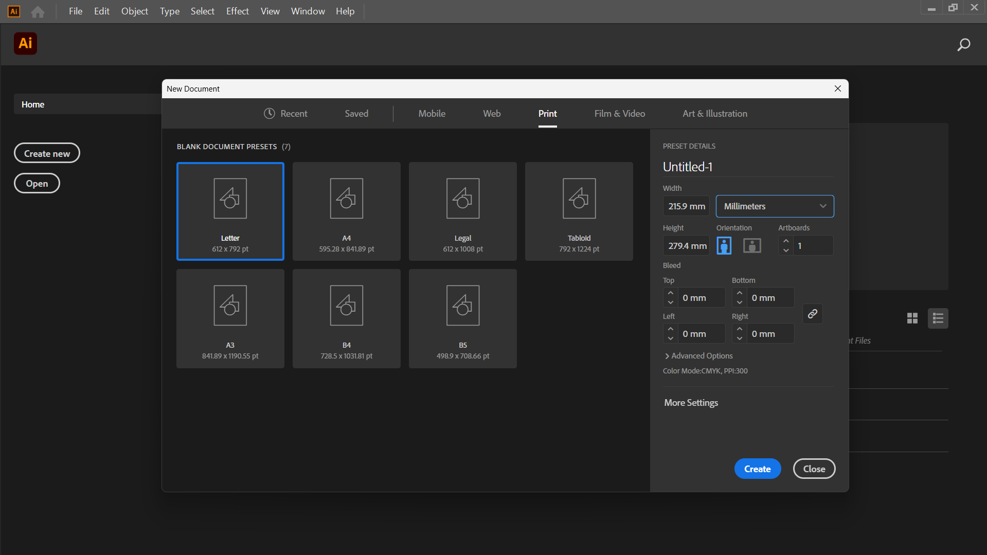

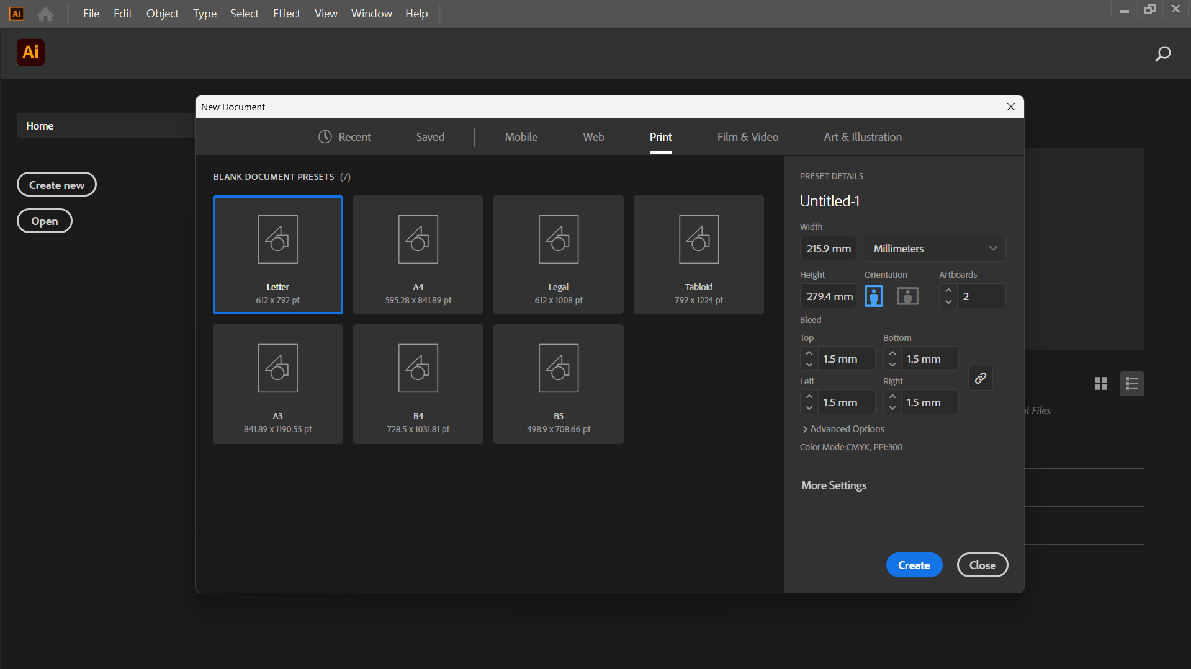

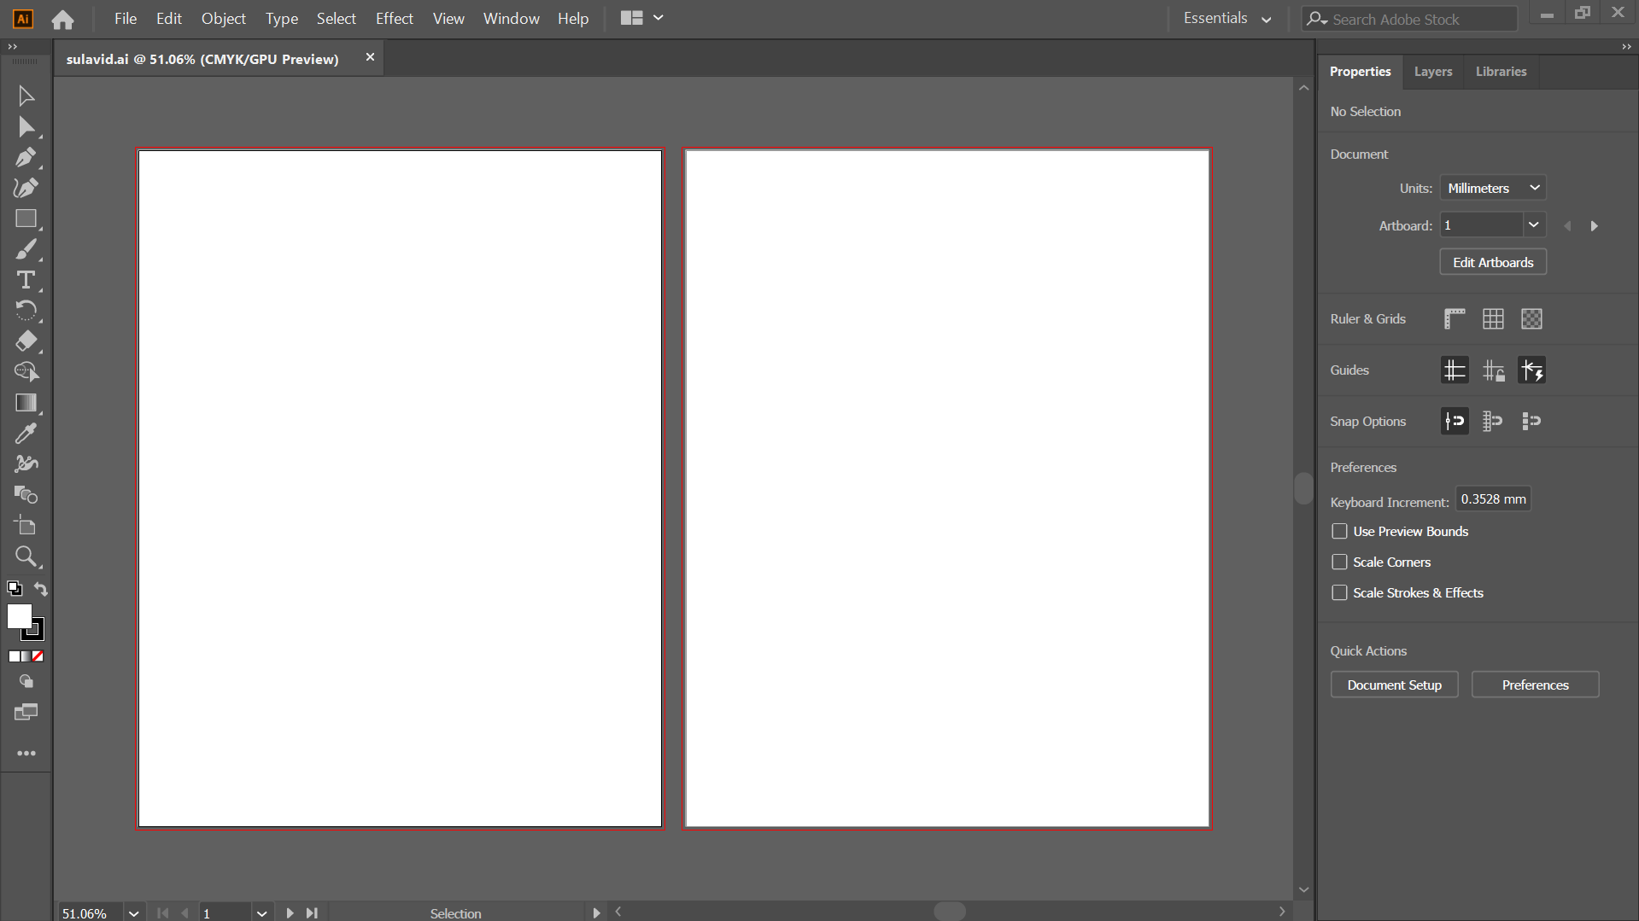

1. 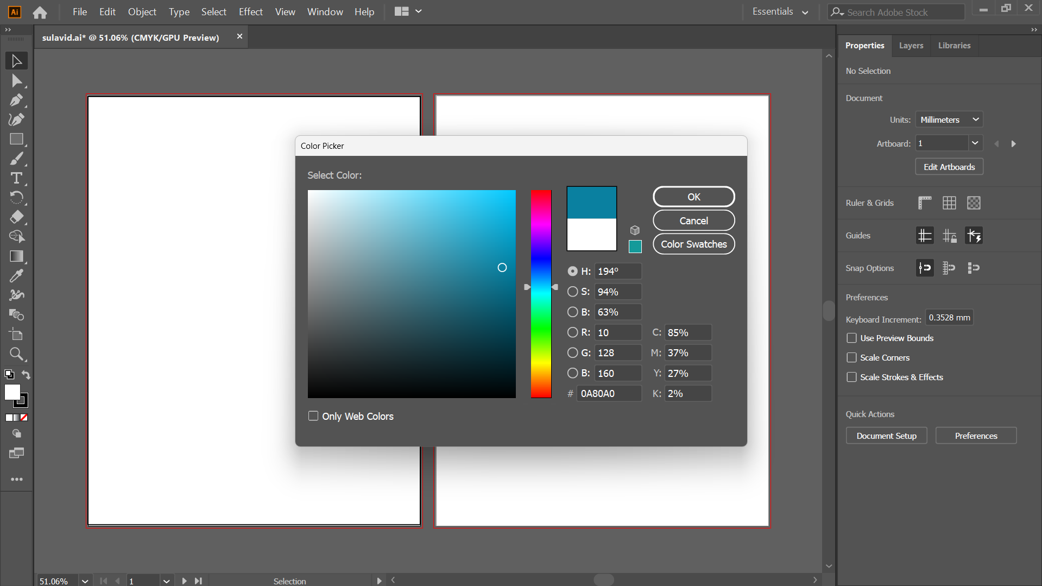Color the both artboard using full as shown below:

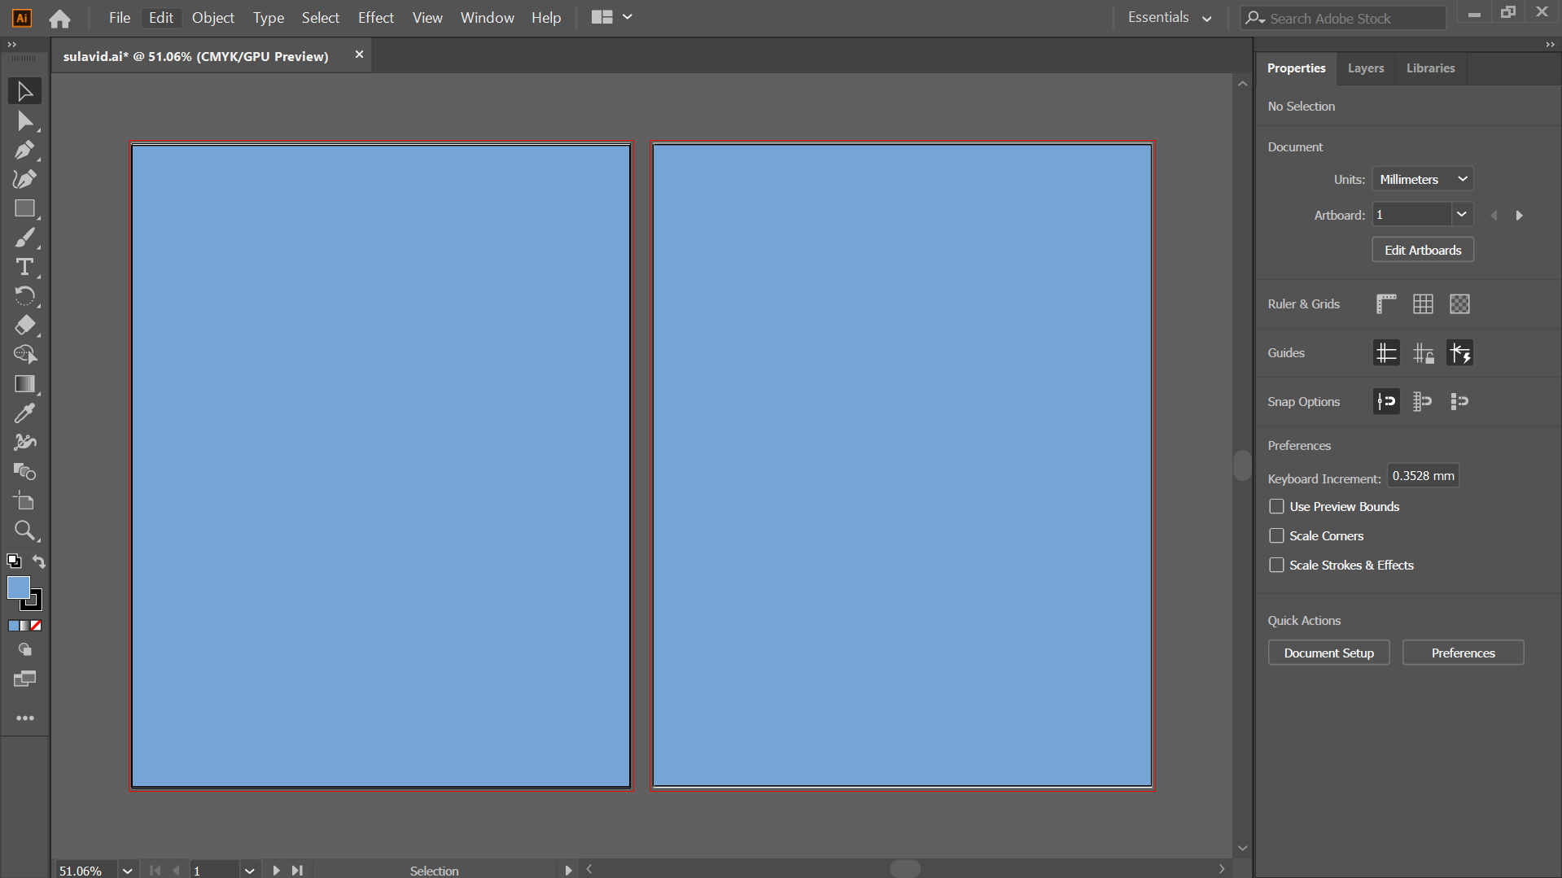

1. Add a rectangle in the 1st artboard:

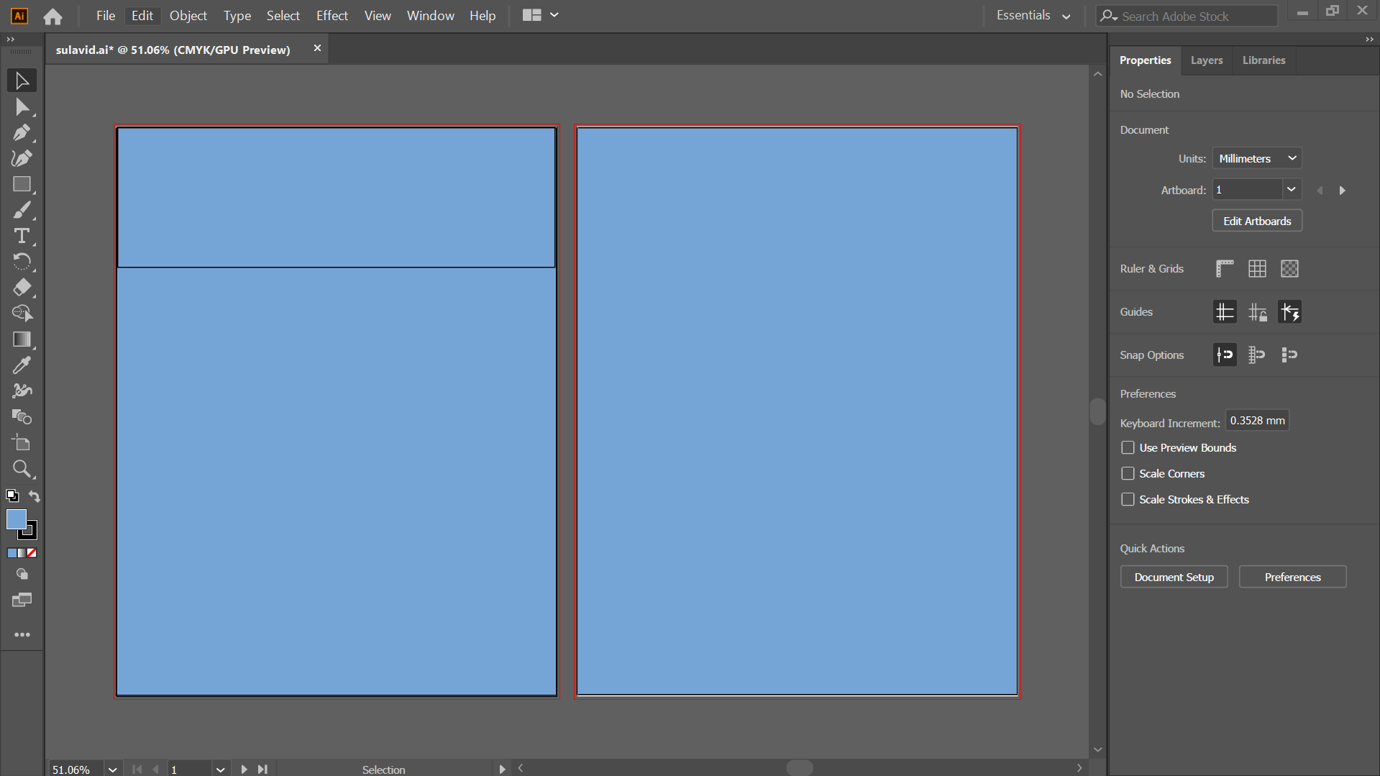

1. Select the path of the small rectangle as below:

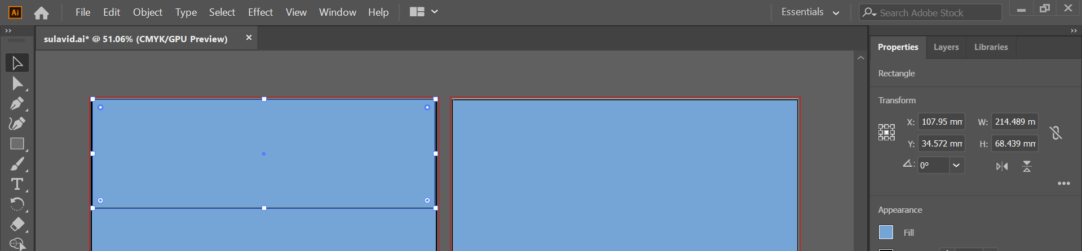

1. Drag the small circle upwards as below:

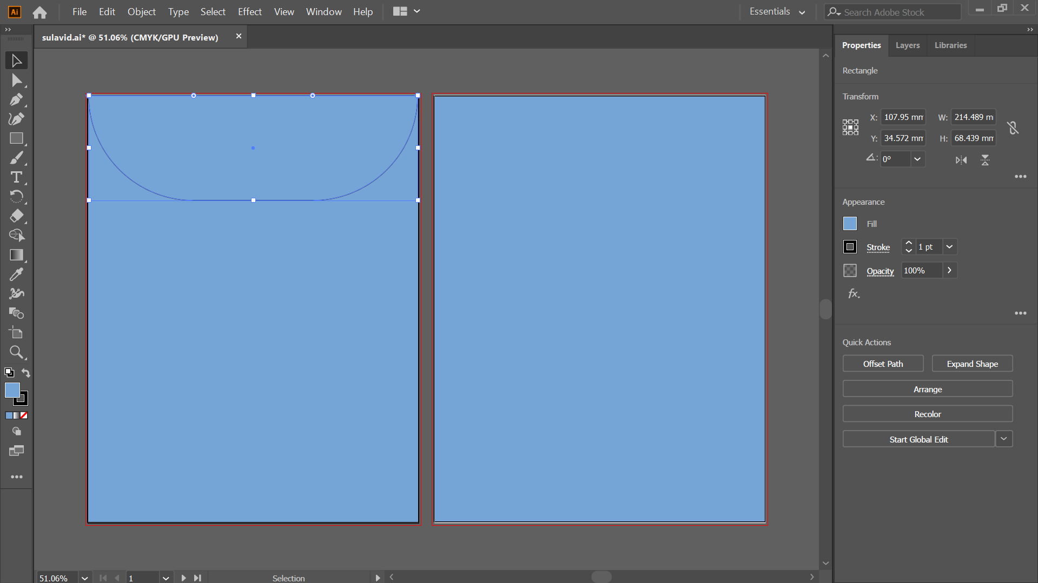

1. Fill the space with white color:

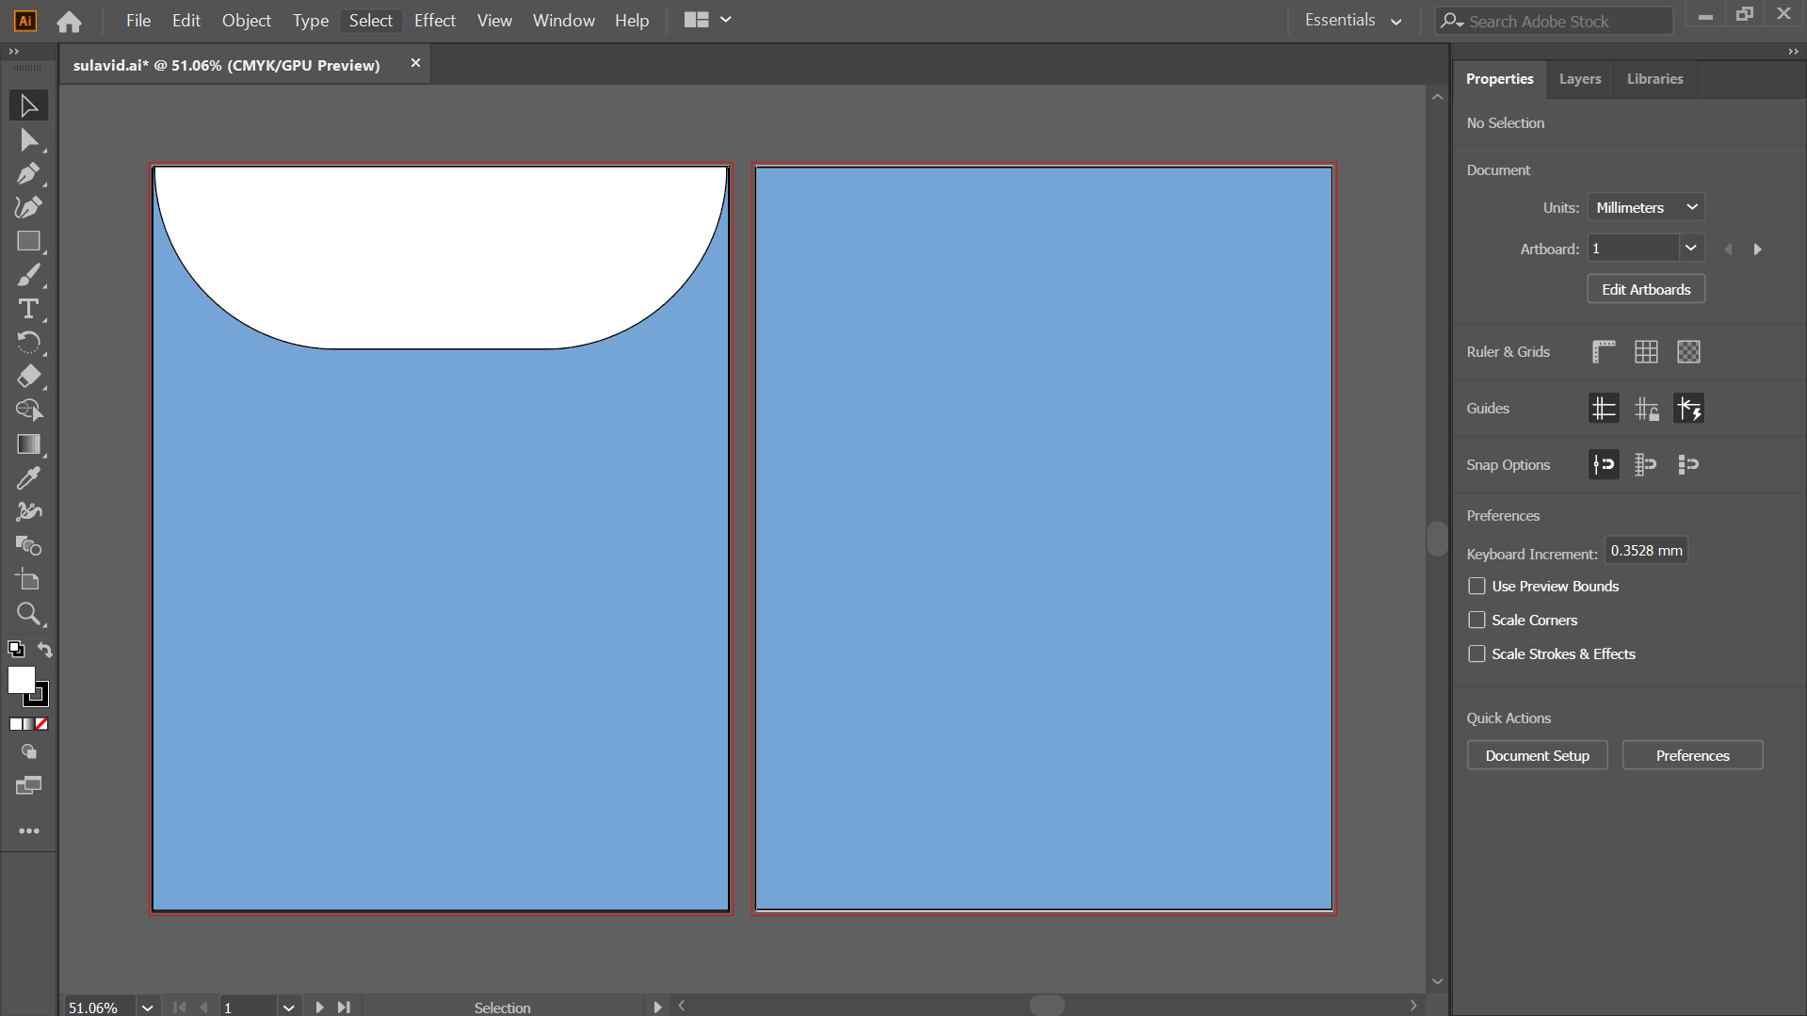

1. Draw an ellipse to insert the image:

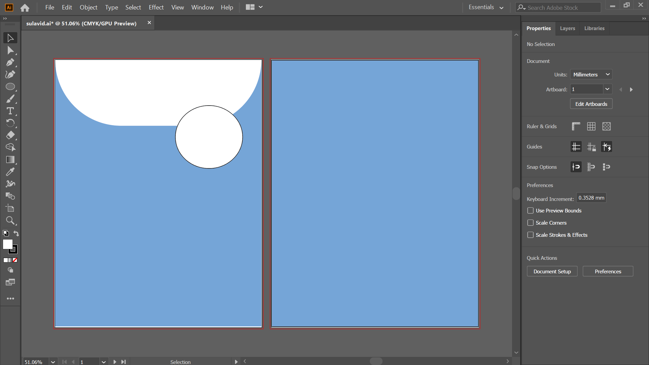

1. Drag and drop a picture to ellipse side by it:

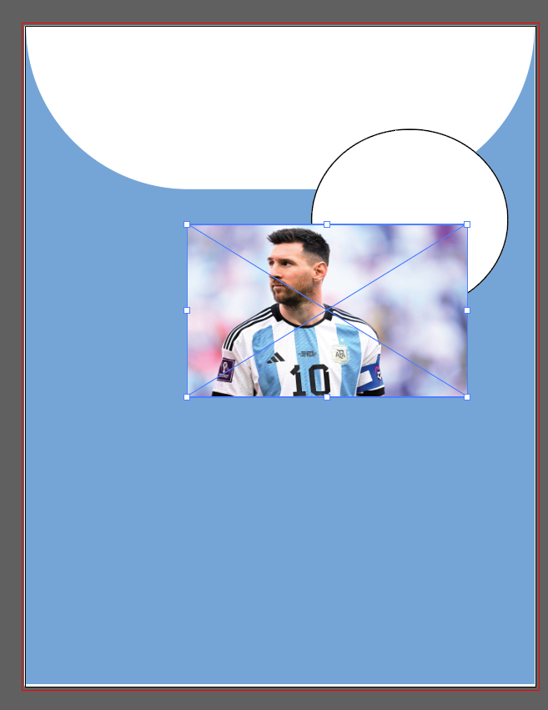

1. Then keep the ellipse in front of the image and select both image and ellipse then right click and use Clipping Mask:

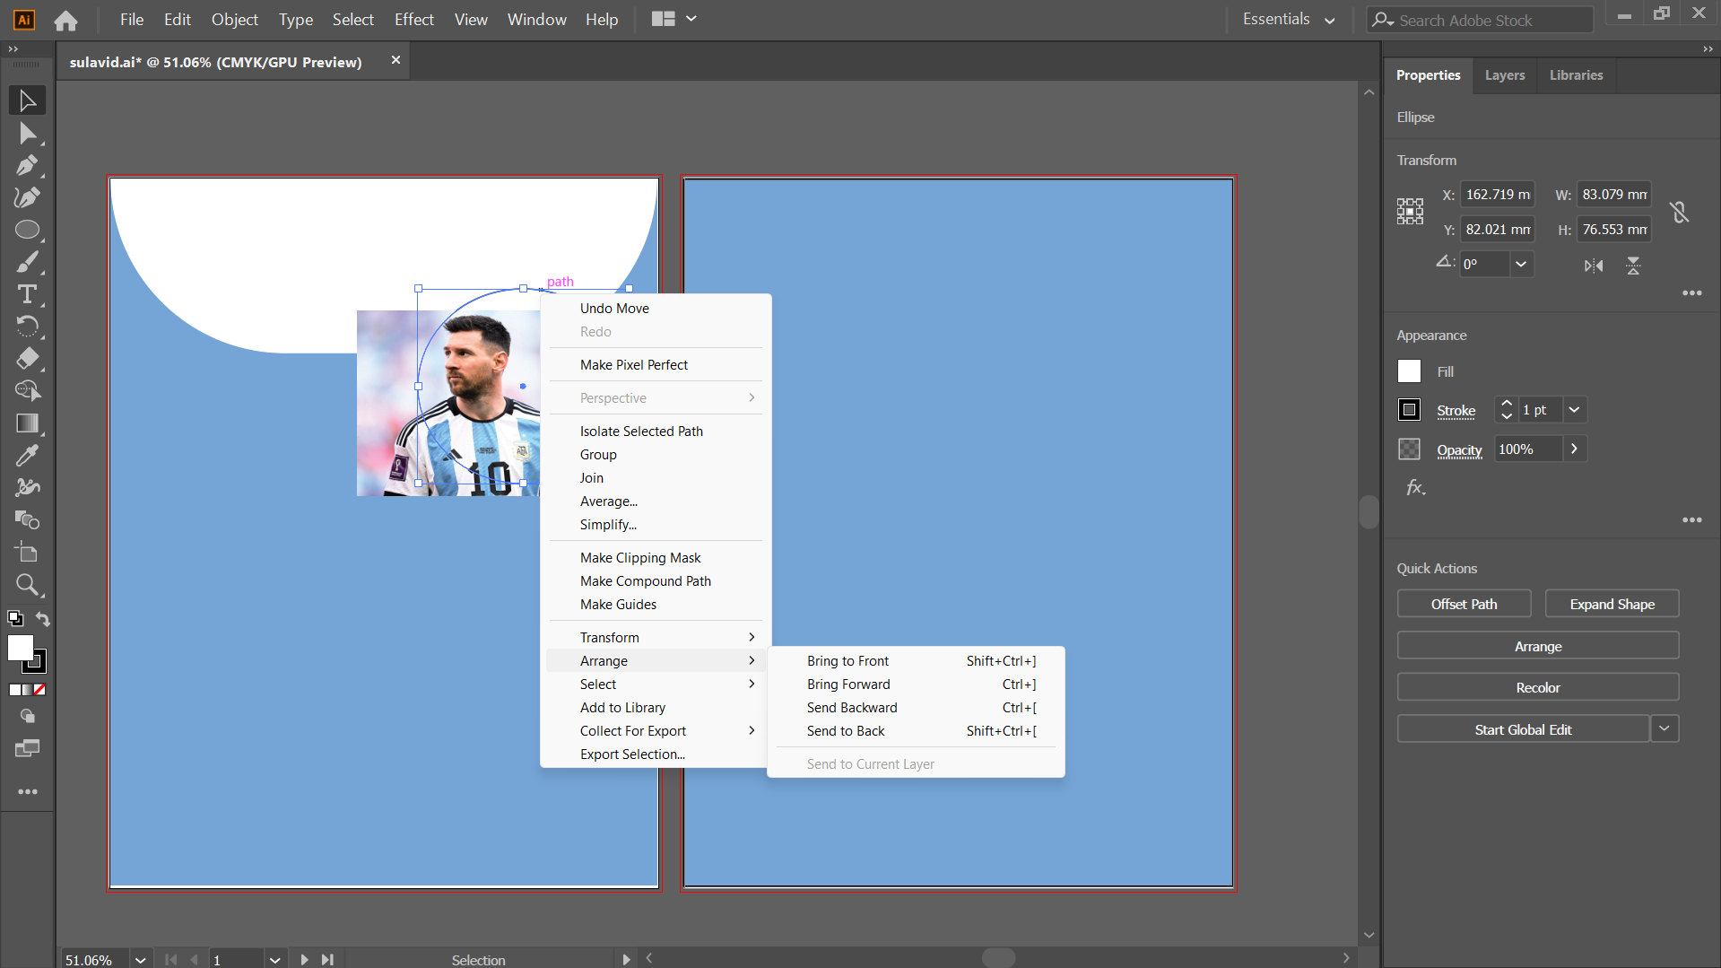

 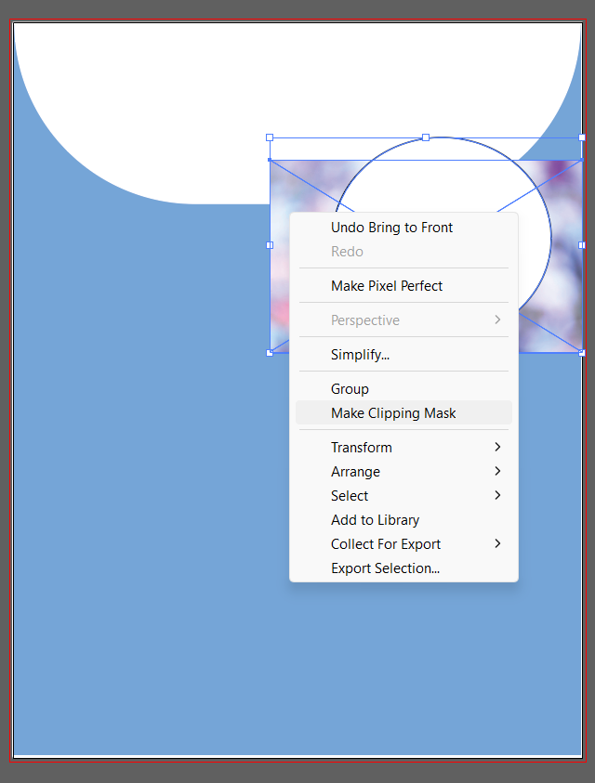

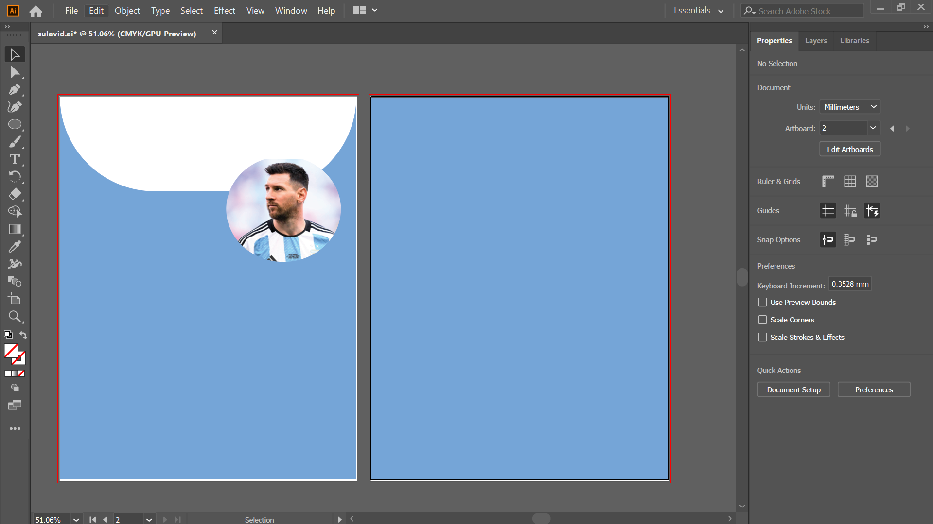

1. Now using the pen tool and drag paint tool from one end to diagonal then release mouse then again drag from that diagonal end point to lower end point then release mouse then again do same from where you started. And full the space with white color. Then you will get as below:

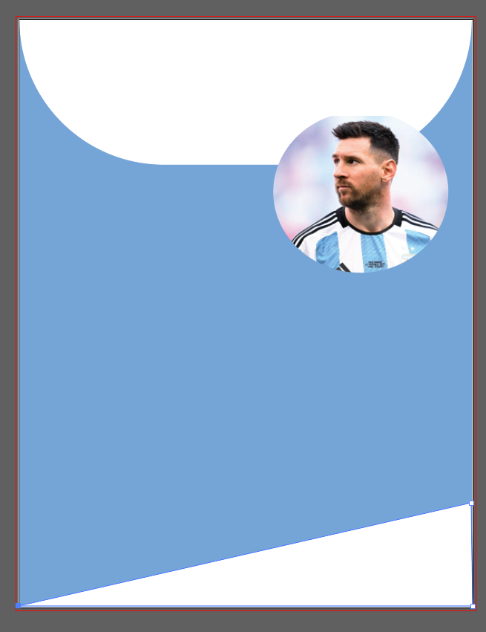

1. Now use text tool to write the college name and description if the id card holder:

1. Now for the back of id card use the step 3,4,5,6 and add the required texts:

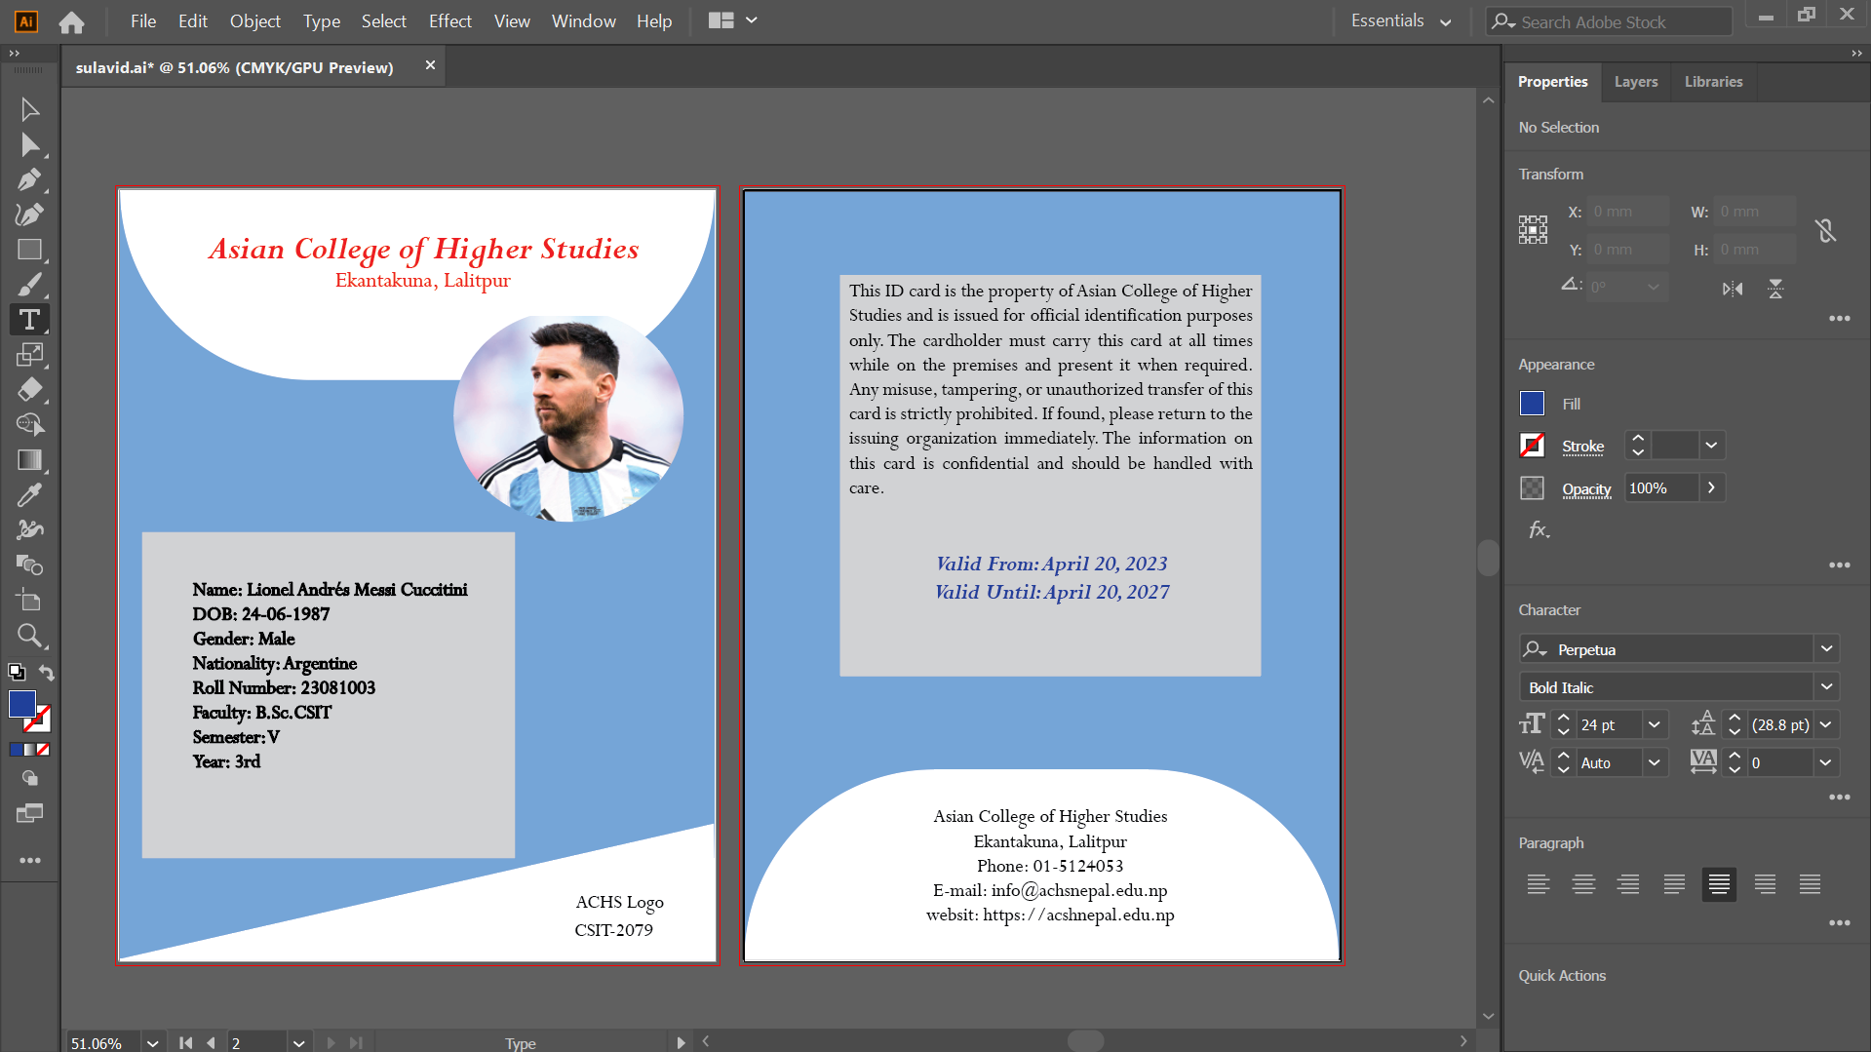

**Conclusion:**

In conclusion, the lab was helpful in learning how to design an ID card using Adobe Illustrator. It provided hands-on experience with basic design tools and showed how to combine text, shapes, and colors in a neat and organized way. The final design is a good example of how Illustrator can be used to create useful and professional-looking materials for everyday use.